**Dr. Mitchell’s Masterminds**

**Weekly Newsletter**

Spelling Words

Doze

Nose

Use

Rose

Pole

Close

Cute

Woke

Mule

Rode

Role

Tune

Home

Joke

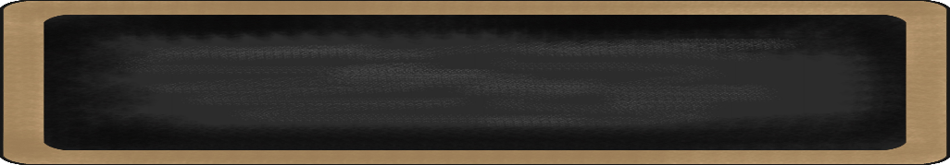s

September 9-13, 2019

MC900134537[1]

Things to Remember

* **Sept. 19 Parent -Teacher Conferences**
* **Sept. 20 ( ½ ) Day for Students!!!**
* **P.E. is on Tuesdays & Fridays. Please remember to dress appropriately and to wear sneakers.**
* **Lunch time is 11:45 -12:15**
* **Send notes for any dismissal changes**
* **EMAIL:** mitchellin@scsk12.org
* **Class website:** http://southwindmasterminds.weebly.com/

|  |  |  |  |  |  |
| --- | --- | --- | --- | --- | --- |
| **Reading** | **Writing** | **Phonics** | **Math** | **Science** | **Social studies** |
| Read, “Off to Class”  **Skill:** Understanding  key details in  text | Informative Writing | Long Vowels  o, U  **Grammar**  Complete sentences with varying punctuations | Measurement | Life Cycle of Animals | Culture, Government, and Civics |

MC900232760[1]

MC900088530[1]

Online Worksheets for At Home Intervention of Current Skills

* <http://www.2ndgradeworksheets.net/freesingledigitadditionworksheets.htm>
* <http://www.2ndgradeworksheets.net/infotext.htm>
* <http://www.2ndgradeworksheets.net/sentencesworksheets.htm>

MC900290705[1]

MC900089728[1]

MC900237619[1]

Vocabulary

**School, teacher, students, learning, books, friends**, **importance, challenge, playing, thinking, sharing, problem, solution**

What we are learning this week:



**Spend time reading aloud with your student. It increases retention, comprehension, and fluency.**