**Dr. Mitchell’s Masterminds**

**Weekly Newsletter**

Spelling Words

Cake

Mine

Plate

Size

Ate

Grape

Prize

Wipe

Race

Line

Pile

Rake

Gave

Bike

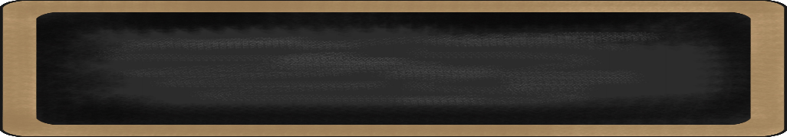s

September 3-6, 2019

MC900134537[1]

Things to Remember

* **9/2 Labor Day (No School)**
* **P.E. is on Tuesdays & Fridays. Please remember to dress appropriately and to wear sneakers.**
* **Lunch time is 11:45 -12:15**
* **Send notes for any dismissal changes**
* **EMAIL:** mitchellin@scsk12.org
* **Class website:** http://southwindmasterminds.weebly.com/

|  |  |  |  |  |  |
| --- | --- | --- | --- | --- | --- |
| **Reading** | **Writing** | **Phonics** | **Math** | **Science** | **Social studies** |
| Read: The Invisible  Boy  **Skill:** Understanding  key details in  text | Informative Writing | Long Vowels  A, I  **Grammar**  Complete sentences with varying punctuations | Measurement | Life Cycle of Animals | Culture, Government, and Civics |

MC900232760[1]

MC900088530[1]

Online Worksheets for At Home Intervention of Current Skills

* <http://www.2ndgradeworksheets.net/freesingledigitadditionworksheets.htm>
* <http://www.2ndgradeworksheets.net/infotext.htm>
* <http://www.2ndgradeworksheets.net/sentencesworksheets.htm>

MC900290705[1]

MC900089728[1]

MC900237619[1]

Vocabulary

**School, teacher, students, learning, books, friends**, **importance, challenge, playing, thinking, sharing**

What we are learning this week:



**Spend time reading aloud with your student. It increases retention, comprehension, and fluency.**