**Dr. Mitchell’s Masterminds**

**Weekly Newsletter**

Spelling Words

1. rock
2. black
3. trick
4. kick
5. full
6. dress
7. neck
8. add
9. spell

10.stuck

11.class

12.doll

13.off

14.will

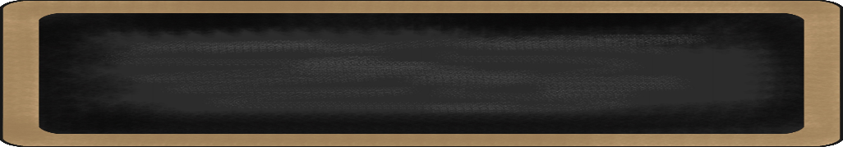

Sept. 30 to Oct. 4, 2019

MC900134537[1]

Things to Remember

* **October 3: SOSA will begin, more info to come…**
* **October 11: End of First Nine Weeks/Report Card Period Ends…**
* **October 11: Half Day, dismissal will start at 1:15/Professional Development**
* **October 11: Absentee Portraits will be taken…**
* **October 14-18: FALL BREAK!!**
* **P.E. is on Tuesdays & Fridays. Please remember to dress appropriately and to wear sneakers.**
* **Lunch time is 11:45 -12:15**
* **Send notes for any dismissal changes**
* **EMAIL:** mitchellin@scsk12.org
* **Class website:** http://southwindmasterminds.weebly.com/

|  |  |  |  |  |  |
| --- | --- | --- | --- | --- | --- |
| **Reading** | **Writing** | **Phonics** | **Math** | **Science** | **Social studies** |
| Schools & Communities: Reading the book, “Off to Class” | Informative Writing | Double consonants and ck, (cvc)  **Grammar:**  Proper Nouns | Understanding Place Value Units of One, Ten, and a Hundred | Animal Habitats  *Changing Habitats* | Geography  Lesson 1  Take Me to the Beach |

MC900232760[1]

Online Worksheets for At Home Intervention of Current Skills

* <http://www.2ndgradeworksheets.net/freesingledigitadditionworksheets.htm>
* <http://www.2ndgradeworksheets.net/infotext.htm>
* <http://www.2ndgradeworksheets.net/sentencesworksheets.htm>

MC900290705[1]

MC900089728[1]

MC900237619[1]

Vocabulary

**Fossils, paleontologist, tools, journaling, research, site, habitat**

What we are learning this week:



**Spend time reading aloud with your student. It increases retention, comprehension, and fluency.**