**Dr. Mitchell’s Masterminds**

**Weekly Newsletter**

Spelling Words

1. I’m
2. don’t
3. isn’t
4. can’t
5. we’ll
6. it’s
7. I’ve
8. didn’t
9. you’re
10. that’s
11. wasn’t
12. you’ve
13. us
14. them

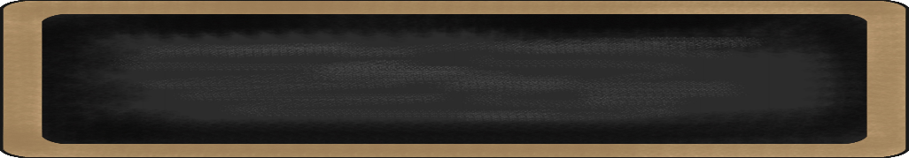

Oct. 28 to Nov. 1, 2019

MC900134537[1]

Things to Remember

* October 30th: Report Cards
* November 1: T-shirt money deadline
* November 15th: Class Picture
* P.E. is on Tuesdays & Fridays. Please remember to dress appropriately and to wear sneakers.
* **Lunch time is 11:55 -12:20**
* **Send notes for any dismissal changes**
* **EMAIL:** mitchellin@scsk12.org
* **Class website:** http://southwindmasterminds.weebly.com/

|  |  |  |  |  |  |
| --- | --- | --- | --- | --- | --- |
| **Reading** | **Writing** | **Phonics** | **Math** | **Science** | **Social studies** |
| The Dog that Dug for Dinosaurs | Informative Writing | contractions  **Grammar:**  Present, past, future tense verbs | Understanding Place Value Units of One, Ten, and a Hundred | Oceans & Fresh Water | Geography:  Lesson 4: Political and Physical Maps |

MC900232760[1]

Online Worksheets for At Home Intervention of Current Skills

* <http://www.2ndgradeworksheets.net/freesingledigitadditionworksheets.htm>
* <http://www.2ndgradeworksheets.net/infotext.htm>
* <http://www.2ndgradeworksheets.net/sentencesworksheets.htm>

MC900290705[1]

MC900089728[1]

MC900237619[1]

Vocabulary

**Fossils, paleontologist, tools, journaling, research, site, habitat, dinosaur, museums**

What we are learning this week:



**Spend time reading aloud with your student. It increases retention, comprehension, and fluency.**