**Dr. Mitchell’s Masterminds**

**Weekly Newsletter**

Spelling Words

free

teach

teeth

please

beach

wheel

team

speak

sneeze

sheep

meaning

weave

eat

read

between

reason

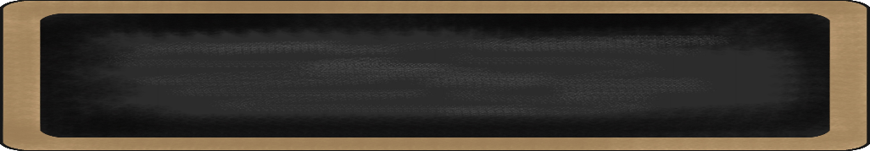

November 18-22, 2019

MC900134537[1]

Things to Remember

* **Nov. 25th- Nov. 29th:** **Thanksgiving Break: No School**
* P.E. is on Tuesdays & Fridays. Please remember to dress appropriately and to wear sneakers.
* **Lunch time is 11:55 -12:20**
* **Send notes for any dismissal changes**
* **EMAIL:** mitchellin@scsk12.org
* **Class website:** http://southwindmasterminds.weebly.com/

|  |  |  |  |  |  |
| --- | --- | --- | --- | --- | --- |
| **Reading** | **Writing** | **Phonics** | **Math** | **Science** | **Social studies** |
| Paleontologist Notebook | Informative & Narrative Writing Pieces | Long Vowel with ee, ea  **Grammar**  Useof Quotations | Vertical Method of Adding & Subtraction, also within a word problem | Slowing Earth’s Changes | Lesson 24: Beliefs, Customs, and Traditions |

MC900232760[1]

Online Worksheets for At Home Intervention of Current Skills

* <http://www.2ndgradeworksheets.net/freesingledigitadditionworksheets.htm>
* <http://www.2ndgradeworksheets.net/infotext.htm>
* <http://www.2ndgradeworksheets.net/sentencesworksheets.htm>

MC900290705[1]

MC900089728[1]

MC900237619[1]

Vocabulary

**Fossils, paleontologist, tools, journaling, research, site, habitat, dinosaur, museums**

What we are learning this week:



**Spend time reading aloud with your student. It increases retention, comprehension, and fluency.**