**Dr. Mitchell’s Masterminds**

**Weekly Newsletter**

Spelling Words

Hens

Eggs

Ducks

Bikes

Boxes

Wishes

Dresses

Names

Bells

Stamps

Dishes

Grapes

Jets

Frogs

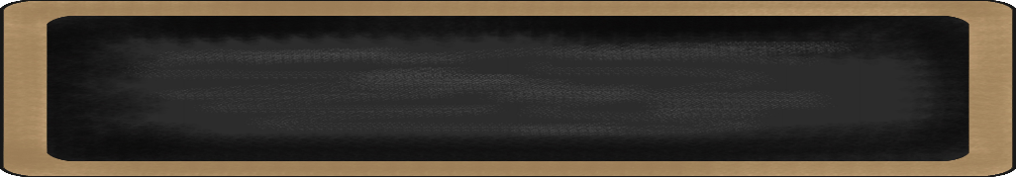

November 1-4, 2019

MC900134537[1]

Things to Remember

* + - * November 7th: K-2nd grade Awards Ceremony 6pm
* November 8th-Half Day
* November 11th: Veterans Day NO SCHOOL
* November 15th: Class Pictures
* P.E. is on Tuesdays & Fridays. Please remember to dress appropriately and to wear sneakers.
* **Lunch time is 11:55 -12:20**
* **Send notes for any dismissal changes**
* **EMAIL:** mitchellin@scsk12.org
* **Class website:** http://southwindmasterminds.weebly.com/

|  |  |  |  |  |  |
| --- | --- | --- | --- | --- | --- |
| **Reading** | **Writing** | **Phonics** | **Math** | **Science** | **Social studies** |
| Curious About Dinosaurs | Informative & Narrative Writing Pieces | Base words and Endings -s, -es **Grammar** Compound Sentences | Sums & Differences within 100 | Oceans & Fresh Water, con’t.  &  Weather, Erosion | Geography:  Lesson 4: Political and Physical Maps |

MC900232760[1]

Online Worksheets for At Home Intervention of Current Skills

* <http://www.2ndgradeworksheets.net/freesingledigitadditionworksheets.htm>
* <http://www.2ndgradeworksheets.net/infotext.htm>
* <http://www.2ndgradeworksheets.net/sentencesworksheets.htm>

MC900290705[1]

MC900089728[1]

MC900237619[1]

Vocabulary

**Fossils, paleontologist, tools, journaling, research, site, habitat, dinosaur, museums**

What we are learning this week:



**Spend time reading aloud with your student. It increases retention, comprehension, and fluency.**