**Dr. Mitchell’s Masterminds**

**Weekly Newsletter**

Spelling Words

night

kind

spy

child

light

find

right

high

wild

July

fry

sigh

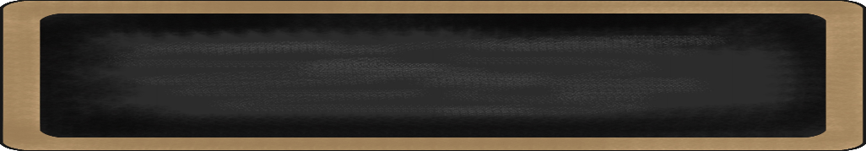

January 13-17, 2020

MC900134537[1]

Things to Remember

* Jan. 17th: Half Day Dismissal at 1:15 p.m.
* Jan. 20th: Dr. King Birthday Observed
  + (No School)
* Jan. 29th : Data Night
* Jan. 29th 100th Day of School
* **P.E. is on Tuesdays & Fridays. Please remember to dress appropriately and to wear sneakers.**
* **Lunch time is 11:45 -12:15**
* **Send notes for any dismissal changes**
* **EMAIL:** mitchellin@scsk12.org
* **Class website:** http://southwindmasterminds.weebly.com/

|  |  |  |  |  |  |
| --- | --- | --- | --- | --- | --- |
| **Reading** | **Writing** | **Phonics** | **Math** | **Science** | **Social studies** |
| Informational Text  The Secret World of Pollination | Informative Writing | Long i: i-, igh, ie, y  **Grammar:**  Subject/verb agreement | Strategies for Adding and Subtracting Within 1,000 | Pushes & Pulls | Lesson 12  Primary and Secondary Sources |

MC900232760[1]

High Frequency Words

any, blue, carry, doing, else, room, studied, sure, teacher, turned

MC900290705[1]

MC900089728[1]

MC900237619[1]

Vocabulary

**Plant germination pollination seedling soil seeds flower fruit**

What we are learning this week:



**😊Spend time reading aloud with your student. It increases retention, comprehension, and fluency.**

**😊Login to http://clever.com/in/scs to complete I-ready Reading and Math. Remember, students need to pass lessons with 70% or higher**