**Dr. Mitchell’s Masterminds**

**Weekly Newsletter**

Spelling Words

running

clapped

stopped

hopping

batted

selling

pinned

cutting

sitting

rubbed

missed

grabbed

mixed

going

wrapped

swelling

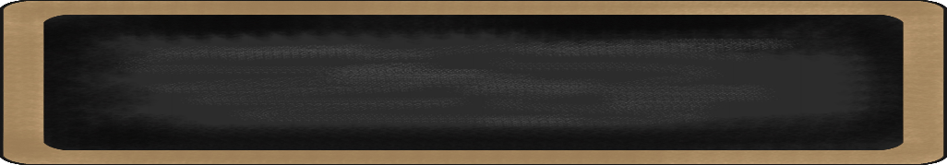

December 2-6, 2019

MC900134537[1]

Things to Remember

* **P.E. is on Tuesdays & Fridays. Please remember to dress appropriately and to wear sneakers.**
* **Lunch time is 11:45 -12:15**
* **Send notes for any dismissal changes**
* **EMAIL:** mitchellin@scsk12.org
* **Class website:** http://southwindmasterminds.weebly.com/

|  |  |  |  |  |  |
| --- | --- | --- | --- | --- | --- |
| **Reading** | **Writing** | **Phonics** | **Math** | **Science** | **Social studies** |
| Reading  Informational Text:  The Secret World  of Pollination | Narrative  Writing | Ed & Ing words  **Grammar:**  Abbreviations (review)  pronouns | Addition & Subtraction within 1,000 with word problems to 100  (Regrouping) | Pushes and Pulls | Lesson 9:  Famous Americans |

MC900232760[1]

High Frequency Words

also, fly, gone, have, horse, look, river, said, saw, something

MC900290705[1]

MC900089728[1]

MC900237619[1]

Vocabulary

**Seeds, pollination, germination, plants**

What we are learning this week:



**Spend time reading aloud with your student. It increases retention, comprehension, and fluency.**