**Dr. Mitchell’s Masterminds**

**Weekly Newsletter**

Spelling Words

Father

Over

Under

Herd

Water

Verb

Paper

Cracker

Offer

Cover

Germ

Master

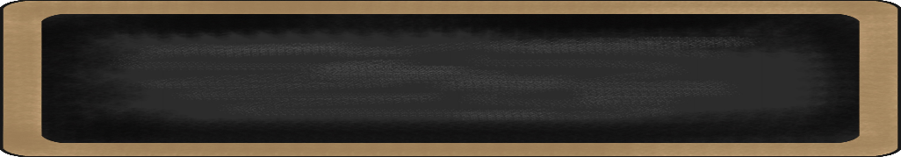

February 10-14, 2020

MC900134537[1]

Things to Remember

* **Feb. 12th : Progress Reports**
* **Feb 13 Parent/Teacher Conference Appt. Only!**
  + **430pm to 700pm**
* **Feb. 14th: Half Day 1:15 p.m.**
* **Feb. 21st: Black History Program**
* **P.E. is on Tuesdays & Fridays. Please remember to dress appropriately and to wear sneakers.**
* **Lunch time is 11:45 -12:15**
* **Send notes for any dismissal changes**
* **EMAIL:** mitchellin@scsk12.org
* **Class website:** http://southwindmasterminds.weebly.com/

|  |  |  |  |  |  |
| --- | --- | --- | --- | --- | --- |
| **Reading** | **Writing** | **Phonics** | **Math** | **Science** | **Social studies** |
| Reading  Informational Text:  The Secret World  of Pollination | Informative  Writing | -ir, -er, -ur words  **Grammar:**  adjectives | Addition & Subtraction within 1,000 with word problems to 100  (Regrouping) | Collisions, con’t. | Lesson 19:  Responsible Citizens, con’t. |

MC900232760[1]

High Frequency Words

Move, house, took, how, voice, nothing, across, one, behind, out

Additional Vocabulary

Noun, adjective, verb, adverb, research, collaborate

MC900290705[1]

MC900089728[1]

MC900237619[1]

Vocabulary

**Seeds, pollination, germination, plants**

What we are learning this week:



**Spend time reading aloud with your student. It increases retention, comprehension, and fluency.**