**Dr. Mitchell’s Masterminds**

**Weekly Newsletter**

Spelling Words

horn

story

fork

score

store

corn

morning

shore

short

born

tore

forget

for

more

report

forceswelling

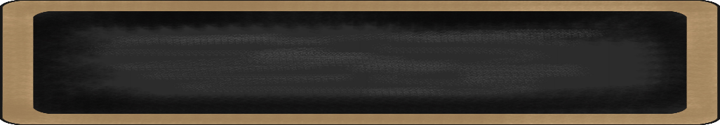

February 3-7, 2020

MC900134537[1]

Things to Remember

* **Feb. 3rd: World’s Finest Chocolate Kickoff**
* **Feb. 12th : Progress Reports**
* **Feb. 14th: Half Day 1:15 p.m.**
* **Feb. 21st: Black History Program**
* **P.E. is on Tuesdays & Fridays. Please remember to dress appropriately and to wear sneakers.**
* **Lunch time is 11:45 -12:15**
* **Send notes for any dismissal changes**
* **EMAIL:** mitchellin@scsk12.org
* **Class website:** http://southwindmasterminds.weebly.com/

|  |  |  |  |  |  |
| --- | --- | --- | --- | --- | --- |
| **Reading** | **Writing** | **Phonics** | **Math** | **Science** | **Social studies** |
| Reading  Informational Text:  The Secret World  of Pollination | Informative  Writing | -or, -ore words  **Grammar:**  Commas in a series | Addition & Subtraction within 1,000 with word problems to 100  (Regrouping) | Collisions | Lesson 19:  Responsible Citizens |

MC900232760[1]

High Frequency Words

I’ve, begins, being, flower, ground, laugh, ready, stood, tall, very

Additional Vocabulary

Noun, adjective, verb, adverb, research, collaborate

MC900290705[1]

MC900089728[1]

MC900237619[1]

Vocabulary

**Seeds, pollination, germination, plants**

What we are learning this week:



**Spend time reading aloud with your student. It increases retention, comprehension, and fluency.**