**Dr. Mitchell’s Masterminds**

**Weekly Newsletter**

Spelling Words

Cannot

Pancake

Maybe

Baseball

Playground

Someone

Myself

Classroom

Sunshine

Outside

Upon

Nothing

Into

Inside

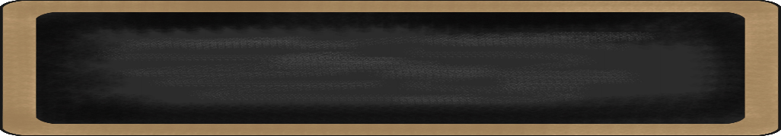

December 2-6, 2019

MC900134537[1]

Things to Remember

* December 20: Report Card Period Ends
* December 20: Half Day, dismissal will start at 1:15/Professional Development
* December-January 23-3: Winter Break
* **P.E. is on Tuesdays & Fridays. Please remember to dress appropriately and to wear sneakers.**
* **Lunch time is 11:45 -12:15**
* **Send notes for any dismissal changes**
* **EMAIL:** mitchellin@scsk12.org
* **Class website:** http://southwindmasterminds.weebly.com/

|  |  |  |  |  |  |
| --- | --- | --- | --- | --- | --- |
| **Reading** | **Writing** | **Phonics** | **Math** | **Science** | **Social studies** |
| Focus on Reading for Test Preparation | Informative Writing | Compound words & Schwa Vowel Sound  **Grammar:**  Abbreviations | Strategies for Decomposing Tens and Hundreds | Forces & Motion | Lesson 7: Regions  (Climate, physical features, population)  Culture, cont. |

MC900232760[1]

High Frequency Words

Book, new, care, off, ever, over, after, small, live, thought

MC900290705[1]

MC900089728[1]

MC900237619[1]

Vocabulary

**Fossils, paleontologist, tools, journaling, research, site, habitat, dinosaur, museums**

What we are learning this week:



**Spend time reading aloud with your student. It increases retention, comprehension, and fluency.**