**Dr. Mitchell’s Masterminds**

**Weekly Newsletter**

Spelling Words

own

most

soap

float

boat

know

loan

goat

flow

loaf

throw

coach

so

grow

swallow

ocean

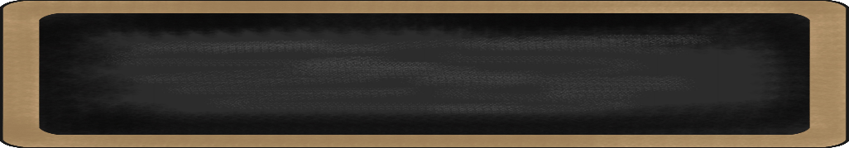

December 2-6, 2019

MC900134537[1]

Things to Remember

* **December 4: Progress Reports**
* **December 20: Half Day (Early Dismissal); End of 2nd 9 weeks**
* **P.E. is on Tuesdays & Fridays. Please remember to dress appropriately and to wear sneakers.**
* **Lunch time is 11:45 -12:15**
* **Send notes for any dismissal changes**
* **EMAIL:** mitchellin@scsk12.org
* **Class website:** http://southwindmasterminds.weebly.com/

|  |  |  |  |  |  |
| --- | --- | --- | --- | --- | --- |
| **Reading** | **Writing** | **Phonics** | **Math** | **Science** | **Social studies** |
| Focus on Reading for Test Preparation | Informative Writing | Long O Sounds  **Grammar:**  Proper Nouns | Strategies for Decomposing Tens and Hundreds | Forces & Motion | Lesson 7: Regions  (Climate, physical features, population)  Culture, cont. |

MC900232760[1]

High Frequency Words

all, food, front, hair, never, party, sky, started, stories, warm

MC900290705[1]

MC900089728[1]

MC900237619[1]

Vocabulary

**Fossils, paleontologist, tools, journaling, research, site, habitat, dinosaur, museums**

What we are learning this week:



**Spend time reading aloud with your student. It increases retention, comprehension, and fluency.**